To access your Tapestry account visit: www.tapestryjournal.com. (You can also find this via google). You should then see the following page:

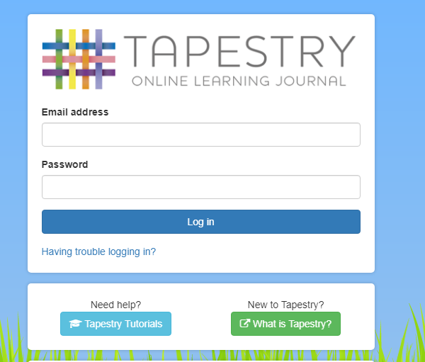
If you are unsure of your log in details or have changed your email address please contact
Cbembridge@benjaminadlard.Anthemtrust.uk
SNoble@benjaminadlard.Anthemtrust.uk

Once logged on you will be able to view your child’s previous observations and will also be able to add your own observations by following the steps below.

Step 1.
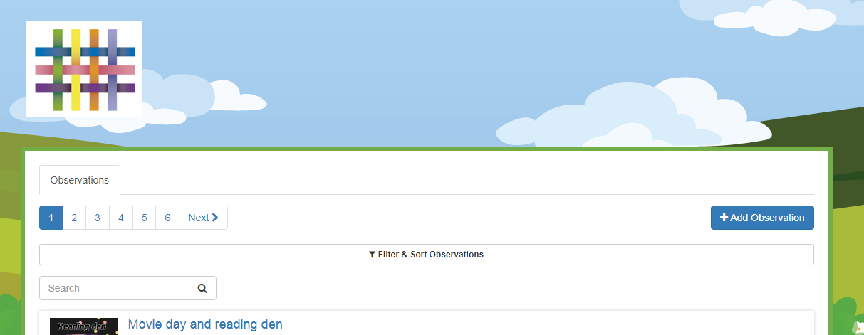
To add an observation click here.
(Your child’s current observations will be visible here)

Step 2.
Your observation must have a title.
Select your child/ children here.
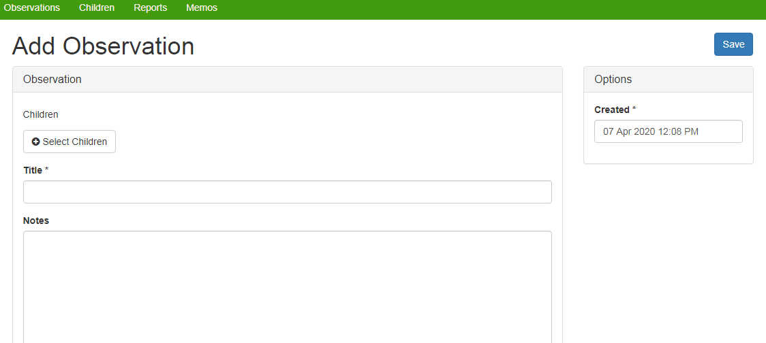
You can write a short sentence here to tell us some more information.

Step 3.
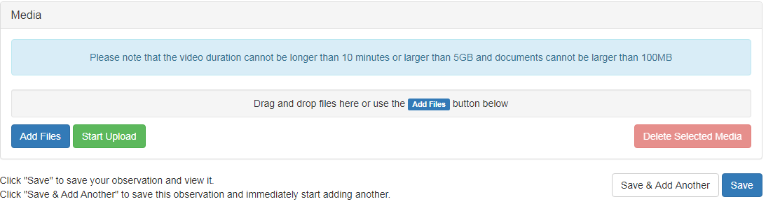
First, click here to select the file you would like to upload.
When you are happy with the file chosen, click ‘start upload’.
Once the file has uploaded you can click save and your observation will be added to your child’s journal.

If you should require any further support please do not hesitate to email on the address provided above.

